LAVEET ENTERPRISES

STEP 1-2 — RAW PROJECT / WORK LIST Completed Projects — 16 entries
ID: | Project / Work: | Source:
P-01: | Improvement Street / Providing & Fixing Paving Block, Ward No. 4, Chaneser Goth, UC-4, Jamshed Town, Karachi  COST OF PROJECT IN MILLION: 2.97  DATE OF START: 2020  ORIGNAL DATE OF COMPLETION: 2020 | Pages 6–7
P-02: | Improvement Street / Providing & Fixing Paving Block, Ward No. 4, Chaneser Goth, UC-4, Jamshed Town, Karachi  COST OF PROJECT IN MILLION: 2.97  DATE OF START: 2020  ORIGNAL DATE OF COMPLETION: 2020 | Pages 6–7
P-03: | Improvement Street / Providing & Fixing Paving Block, Ward No. 4, Chaneser Goth, UC-4, Jamshed Town, Karachi  COST OF PROJECT IN MILLION: 2.98  DATE OF START: 2020  ORIGNAL DATE OF COMPLETION: 2020 | Pages 6–7
P-04: | Improvement Street / Providing & Fixing Paving Block, Ward No. 4, Chaneser Goth, UC-4, Jamshed Town, Karachi  COST OF PROJECT IN MILLION: 2.98  DATE OF START: 2020  ORIGNAL DATE OF COMPLETION: 2020 | Pages 6–7
P-05: | Improvement Street / Providing & Fixing Paving Block, Ward No. 4, Chaneser Goth, UC-4, Jamshed Town, Karachi  COST OF PROJECT IN MILLION: 2.98  DATE OF START: 2020  ORIGNAL DATE OF COMPLETION: 2020 | Pages 6–7
P-06: | Improvement Street / Providing & Fixing Paving Block, Ward No. 4, Chaneser Goth, UC-4, Jamshed Town, Karachi  COST OF PROJECT IN MILLION: 2.98  DATE OF START: 2020  ORIGNAL DATE OF COMPLETION: 2020 | Pages 6–7
P-07: | Improvement Street / Providing & Fixing Paving Block, Ward No. 4, Chaneser Goth, UC-4, Jamshed Town, Karachi  COST OF PROJECT IN MILLION: 2.98  DATE OF START: 2020  ORIGNAL DATE OF COMPLETION: 2020 | Pages 6–7
P-08: | Improvement Street / Providing & Fixing Paving Block, Ward No. 4, Chaneser Goth, UC-4, Jamshed Town, Karachi  COST OF PROJECT IN MILLION: 2.97  DATE OF START: 2020  ORIGNAL DATE OF COMPLETION: 2020 | Pages 6–7
P-09: | Improvement Street / Providing & Fixing Paving Block, Ward No. 4, Chaneser Goth, UC-4, Jamshed Town, Karachi  COST OF PROJECT IN MILLION: 2.98  DATE OF START: 2020  ORIGNAL DATE OF COMPLETION: 2020 | Pages 6–7
P-10: | Improvement Street / Providing & Fixing Paving Block, Ward No. 4, Chaneser Goth, UC-4, Jamshed Town, Karachi  COST OF PROJECT IN MILLION: 2.98  DATE OF START: 2020  ORIGNAL DATE OF COMPLETION: 2020 | Pages 6–7
P-11: | Construction of Residential Accommodation for Constable & Head Constable in Karachi (616 Nos.), PHQ Garden Karachi, Karachi Police — 20 Flats, G+4  COST OF PROJECT IN MILLION: 34.282  DATE OF START: 2016  ORIGNAL DATE OF COMPLETION: 2018 | Page 7
P-12: | Construction of Police Station (Category-C) at Pirabad, Karachi — Main Building, Ground Floor, First Floor & Compound Wall  COST OF PROJECT IN MILLION: 25.244  DATE OF START: 2017  ORIGNAL DATE OF COMPLETION: 2015 | Page 7
P-13: | Repair / Renovation of School in Existing Primary School at GBPS Shah Faisal Jamia Mallia, Karachi  COST OF PROJECT IN MILLION: 18.604  DATE OF START: 2013  ORIGNAL DATE OF COMPLETION: 2015 | Page 7
P-14: | Re-Construction of Dangerous School in Existing Primary School at GBPS Natha Khan, Shah Faisal Town, Karachi  COST OF PROJECT IN MILLION: 18.398  DATE OF START: 2013  ORIGNAL DATE OF COMPLETION: 2015 | Page 7
P-15: | Up-Gradation of Middle School to High School at GBMS Rehri Bakhtawar Goth, Bin Qasim Town, Karachi  COST OF PROJECT IN MILLION: 5.15  DATE OF START: 2014  ORIGNAL DATE OF COMPLETION: 2015 | Page 7
P-16: | Renovation of Government Degree Boys College Moro  COST OF PROJECT IN MILLION: 2.481  DATE OF START: 2016  ORIGNAL DATE OF COMPLETION: 2016  ( P1<->P2<->P8 ---- Possible duplicate )  ( P3<->P4<->P5<->P6<->P7<->P9<->P10 ---- Possible duplicate )  Work in Hand — 3 entries  These are recorded separately exactly as the document presents them. We are NOT saying they are currently ongoing. | Page 7
  ID | Project / Work | Source
  P- 17 | Strengthening & Improvement of 50-Bedded Hospital, Azam Basti, Jamshed Town, Karachi — Main Building including all Services  COST OF PROJECT IN MILLION: 32.751  DATE OF START: 2019  ORIGNAL DATE OF COMPLETION: 2020 | Page 27
  P-18 | Construction of Rooms for Keeping the Spouses with Convicted Prisoners in Sindh at Central Prison, Karachi — 10 Family Rooms including Compound Wall  COST OF PROJECT IN MILLION: 20.444  DATE OF START: 2017  ORIGNAL DATE OF COMPLETION: 2020 | Page 27
  P-19 | Construction of Residential Accommodation for Constable & Head Constable in Karachi (616 Nos.) at PHQ Garden Karachi — 20 Flats, G+4 — Miscellaneous Civil Work  COST OF PROJECT IN MILLION: 4.60  DATE OF START: 2018  ORIGNAL DATE OF COMPLETION: 2019 | Page 27

STEP 3 ---- Master Record
P1<->P2<->P8 ---- (Possible duplicate) ---- Initial Master Record
Field | Information
Project ID | P-01 , P-02 , P-08
Official Project Name | Improvement Street / Providing & Fixing Paving Block
Project Type | Road / Street Improvement
Location | Ward No. 4, Chaneser Goth, UC-4, Jamshed Town, Karachi
Client / Department | Not found
Consultant | Not found
Project Value | Not found
Start Date | 2020
Completion Date | 2020
Status | Completed
Scope | Street improvement / paving block work
Source | Company Profile, Pages 6–7
Photos | Not found
Evidence Strength | Needs detailed verification
Duplicate Check | Pending
Website Recommendation | Pending
Open Issues | P1<->P2<->P8 and P3<->P4<->P5<->P6<->P7<->P9<->P10 have very similar/repeated descriptions and must be compared before deciding whether they are separate projects.

P3<->P4<->P5<->P6<->P7<->P9<->P10 ---- Possible duplicate ---- Initial Master Record
Field | Information
Project ID | P-03 , P-04 , P-05 , P-06 , P-07 , P-09 , P-10
Official Project Name | Improvement Street / Providing & Fixing Paving Block
Short Name | Street Improvement / Paving Block
Project Type | Road / Street Improvement
Location | Ward No. 4, Chaneser Goth, UC-4, Jamshed Town, Karachi
Client / Department | Not found
Consultant | Not found
Project Value | Not found
Start Date | 2020
Completion Date | 2020
Status | Completed
Scope | Improvement Street / Providing & Fixing Paving Block
Source Pages | Pages 6–7
Supporting Documents | Detailed work-order pages 8–17 — verification pending
Photos / Photo IDs | Not mapped yet
Evidence Strength | Preliminary
Duplicate Check | Possible duplicate with P1<->P2<->P8 — pending evidence comparison

P-11 — Initial Master Record
Field | Information
Project ID | P-11
Official Project Name | Construction of Residential Accommodation for Constable & Head Constable in Karachi (616 Nos.)
Short Name | Police Residential Accommodation — PHQ Garden
Project Type | Residential / Government Building
Location | PHQ Garden, Karachi
Client / Department | Karachi Police & Prison
Consultant | Not found
Project Value | 34.282 Million
Start Date | 2016
Completion Date | 2018
Status | Completed
Scope | Construction of 20 Flats, G+4
Source Pages | Page 7
Supporting Documents | Not yet fully mapped
Photos / Photo IDs | Not mapped yet
Evidence Strength | Preliminary
Duplicate Check | Not found
Website Recommendation | Not found
Open Issues | Need to verify detailed project documents, dates, value and relationship to P-19.

P-12 — Initial Master Record
Field | Information
Project ID | P-12
Official Project Name | Construction of Police Station (Category-C) at Pirabad, Karachi
Short Name | Pirabad Police Station
Project Type | Police / Government Building
Location | Pirabad, Karachi
Client / Department | Karachi Police & Prison
Consultant | Not found
Project Value | 25.244 Million
Start Date | 2017
Completion Date | 2015
Status | Completed
Scope | Main Building, Ground Floor, First Floor & Compound Wall
Source Pages | Page 7
Supporting Documents | Not yet mapped
Photos / Photo IDs | Not mapped yet
Evidence Strength | Preliminary
Duplicate Check | Not found
Website Recommendation | Not found
Open Issues | Client, value, dates and supporting evidence need verification.

P-13 — Initial Master Record
Field | Information
Project ID | P-13
Official Project Name | Repair/Renovation of School in Existing Primary School at GBPS Shah Faisal Jamia Mallia, Karachi
Short Name | GBPS Shah Faisal Jamia Mallia
Project Type | Education / School
Location | Shah Faisal Jamia Mallia, Karachi
Client / Department | EDU-III
Consultant | Not found
Project Value | 18.604 Million
Start Date | 2013
Completion Date | 2015
Status | Completed
Scope | Repair / Renovation
Source Pages | Page 7
Supporting Documents | Not yet mapped
Photos / Photo IDs | Not mapped yet
Evidence Strength | Preliminary
Duplicate Check | Not found
Website Recommendation | Not found
Open Issues | Detailed project evidence, value, client and dates need verification.

P-14 — Initial Master Record
Field | Information
Project ID | P-14
Official Project Name | Re-Construction of Dangerous School in Existing Primary School at GBPS Natha Khan, Shah Faisal Town, Karachi
Short Name | GBPS Natha Khan
Project Type | Education / School
Location | Natha Khan, Shah Faisal Town, Karachi
Client / Department | EDU-III
Consultant | Not found
Project Value | 18.398 Million
Start Date | 2013
Completion Date | 2015
Status | Completed
Scope | Re-construction of dangerous school
Source Pages | Page 7
Supporting Documents | Not yet mapped
Photos / Photo IDs | Not mapped yet
Evidence Strength | Preliminary
Duplicate Check | Not found
Website Recommendation | Not found
Open Issues | Detailed project evidence, value, client and dates need verification.

P-15 — Initial Master Record
Field | Information
Project ID | P-15
Official Project Name | Up-Gradation of Middle School to High School at GBMS Rehri Bakhtawar Goth, Bin Qasim Town, Karachi
Short Name | GBMS Rehri Bakhtawar Goth
Project Type | Education / School
Location | Rehri Bakhtawar Goth, Bin Qasim Town, Karachi
Client / Department | EDU-III
Consultant | Not found
Project Value | 5.15 Million
Start Date | 2014
Completion Date | 2015
Status | Completed
Scope | Up-gradation from middle school to high school
Source Pages | Page 7
Supporting Documents | Not yet mapped
Photos / Photo IDs | Not mapped yet
Evidence Strength | Preliminary
Duplicate Check | Not found
Website Recommendation | Not found
Open Issues | Detailed project evidence, value, client and dates need verification.

P-16 — Initial Master Record
Field | Information
Project ID | P-16
Official Project Name | Renovation of Government Degree Boys College Moro
Short Name | Government Degree Boys College Moro
Project Type | Education / College
Location | Moro
Client / Department | EDU-Literacy Dept
Consultant | Not found
Project Value | 2.481 Million
Start Date | 2016
Completion Date | 2016
Status | Not yet verified
Scope | Renovation
Source Pages | Page 7
Supporting Documents | Not yet mapped
Photos / Photo IDs | Not mapped yet
Evidence Strength | Preliminary
Duplicate Check | Not found
Website Recommendation | Not found
Open Issues | Detailed project evidence, value, client and dates need verification.
Step 4 — Duplicate & Relationship Check
P1<->P2<->P8 ---- Possible duplicate

P3<->P4<->P5<->P6<->P7<->P9<->P10 ---- Possible duplicate

P-11 ---- Separate Projects

P-12 ---- Separate Projects
P-13 ---- Separate Projects
P-14 ---- Separate Projects
P-15 ---- Separate Projects
P-16 ---- Separate Projects

Step 5 — Check for Conflicts

First known conflict: Company dates
There is already one important conflict in the company material:
Source | Information
Company Introduction | Established 2009
Company Profile | Year of registration 2008
Conflict recorded 2008 vs 2009
We do not decide which year is correct yet.

Conflict Log entry
Issue: Company establishment/registration year differs.
Values: 2008 vs 2009
Action required: Confirm the correct official year from company/legal documentation.
Status: Open
This is a company-level conflict, not a project conflict, but it belongs in our Issues/Conflict Log.

P1<->P2<->P8 ---- Same project name, location, project value, star and completion dates, status

P3<->P4<->P5<->P6<->P7<->P9<->P10 ---- Same project name, location, project value, star and completion dates, status

Project | Conflict status
P-11 | No conflict identified yet
P-12 | No conflict identified yet
P-13 | No conflict identified yet
P-14 | No conflict identified yet
P-15 | No conflict identified yet
P-16 | No conflict identified yet

Step 6 — Verify Dates
P1<->P2<->P8 ---- Start Date: 2020 , Completion Date: 2020 , Status: Completed
P3<->P4<->P5<->P6<->P7<->P9<->P10 ---- Start Date: 2020 , Completion Date: 2020 , Status: Completed
Project | Start Date | Completion Date | Status
P-11 | 2016 | 2018 | Completed
P-12 | 2017 | 2015 | Completed
P-13 | 2013 | 2015 | Completed
P-14 | 2013 | 2015 | Completed
P-15 | 2014 | 2015 | Completed
P-16 | 2016 | 2016 | Completed

Step 7 — Determine Project Status
P1<->P2<->P8 ---- Status: Completed
P3<->P4<->P5<->P6<->P7<->P9<->P10 ---- Status: Completed

Project | Current source status | Our status
P-11 | Works Carried Out | Completed — source-listed
P-12 | Works Carried Out | Completed — source-listed
P-13 | Works Carried Out | Completed — source-listed
P-14 | Works Carried Out | Completed — source-listed
P-15 | Works Carried Out | Completed — source-listed
P-16 | Works Carried Out | Completed — source-listed

Step 8 — Identify Actual Scope

P-01
Scope: Improvement of street / providing and fixing paving blocks.

P-02
Scope: Improvement of street / providing and fixing paving blocks.

P-03
Scope: Improvement of street / providing and fixing paving blocks.

P-04
Scope: Improvement of street / providing and fixing paving blocks.

P-05
Scope: Improvement of street / providing and fixing paving blocks.

P-06
Scope: Improvement of street / providing and fixing paving blocks.

P-07
Scope: Improvement of street / providing and fixing paving blocks.

P-08
Scope: Improvement of street / providing and fixing paving blocks.

P-09
Scope: Improvement of street / providing and fixing paving blocks.

P-10
Scope: Improvement of street / providing and fixing paving blocks.
Note for P-01–P-10: The descriptions are currently the same in our raw records. We have not assumed they are the same project. Their individual work orders still need to be compared.

P-11
Scope: Construction of 20 Flats, G+4 for residential accommodation for Constable & Head Constable.

P-12
Scope: Construction of a Category-C Police Station, including:
- Main Building
- Ground Floor
- First Floor
- Compound Wall

P-13
Scope: Repair / renovation of the existing primary school at GBPS Shah Faisal Jamia Mallia.

P-14
Scope: Re-construction of the dangerous existing primary school at GBPS Natha Khan, Shah Faisal Town.

P-15
Scope: Up-gradation of Middle School to High School at GBMS Rehri Bakhtawar Goth.

P-16
Scope: Renovation of Government Degree Boys College Moro.

STEP 9 ---- Photograph-to-Project Mapping
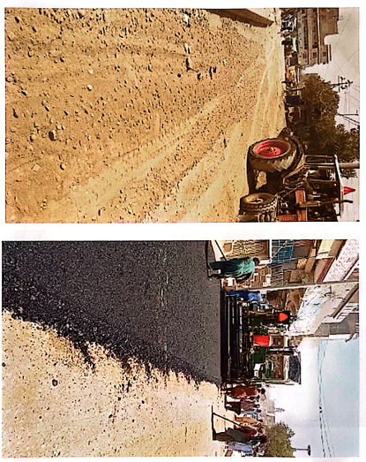
Photo ID: Pic-1
Project ID: Not found
What the photo shows:
Before / During / After:
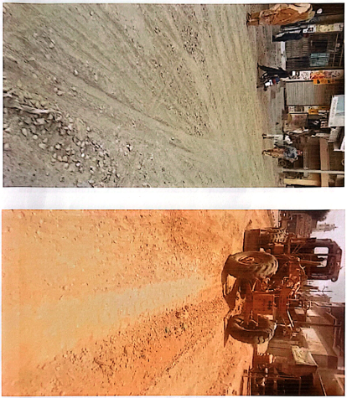
Photo ID: Pic-2
Project ID: Not found
What the photo shows:
Before / During / After:
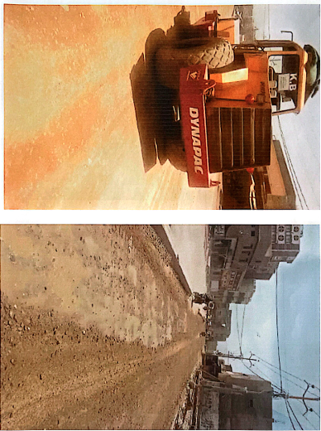
Photo ID: Pic-3
Project ID: Not found
What the photo shows:
Before / During / After:

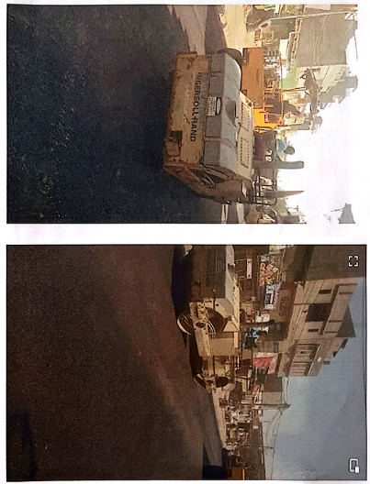
Photo ID: Pic-4
Project ID: Not found
What the photo shows:
Before / During / After:

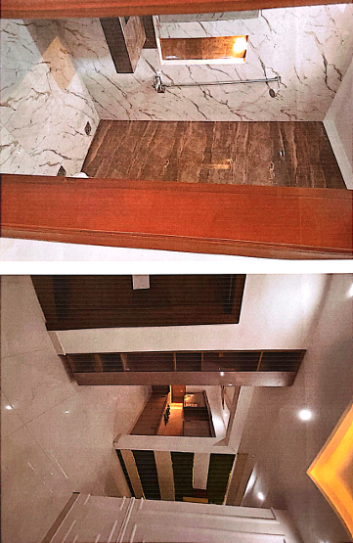
Photo ID: Pic-5
Project ID: Not found
What the photo shows:
Before / During / After:

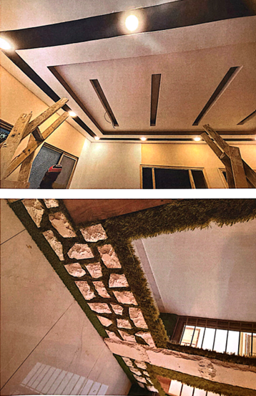
Photo ID: Pic-6
Project ID: Not found
What the photo shows:
Before / During / After:
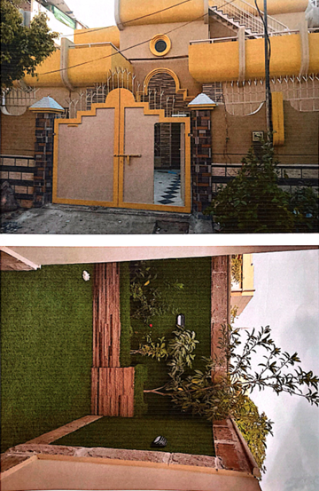
Photo ID: Pic-7
Project ID: Not found
What the photo shows:
Before / During / After:
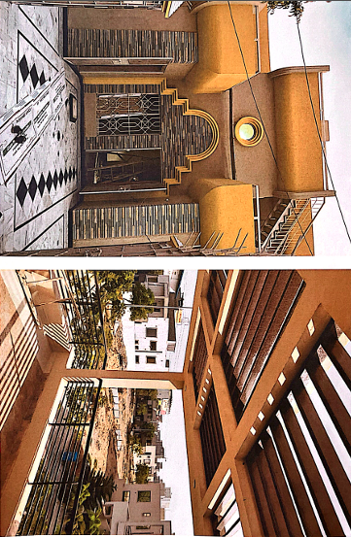
Photo ID: Pic-8
Project ID: Not found
What the photo shows:
Before / During / After:
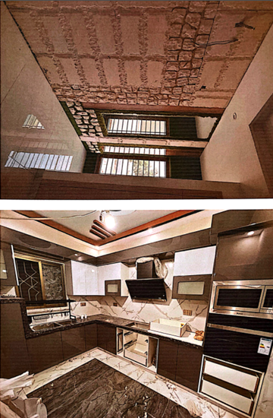
Photo ID: Pic-9
Project ID: Not found
What the photo shows:
Before / During / After:
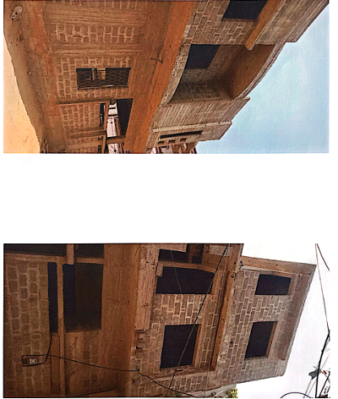
Photo ID: Pic-10
Project ID: Not found
What the photo shows:
Before / During / After:

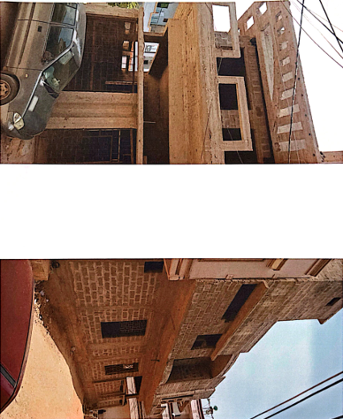
Photo ID: Pic-11
Project ID: Not found
What the photo shows:
Before / During / After:
Police & Prison Works Sindh:
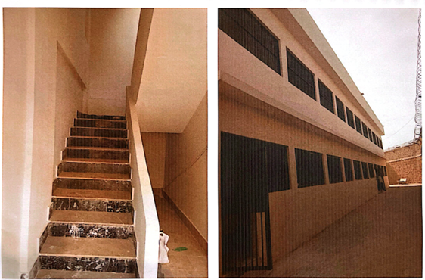
Photo ID: Pic-12
Project ID: Not found
What the photo shows:
Before / During / After:

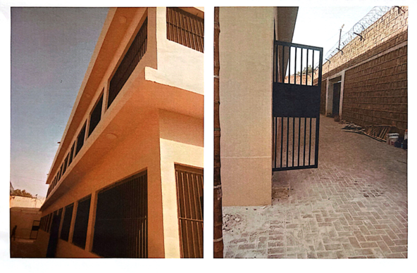
Photo ID: Pic-13
Project ID: Not found
What the photo shows:
Before / During / After:

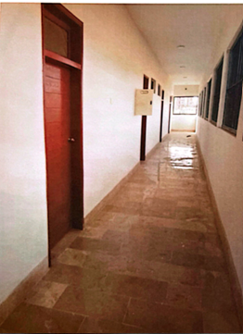
Photo ID: Pic-14
Project ID: Not found
What the photo shows:
Before / During / After:
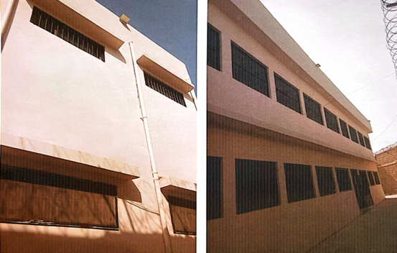
Photo ID: Pic-15
Project ID: Not found
What the photo shows:
Before / During / After:

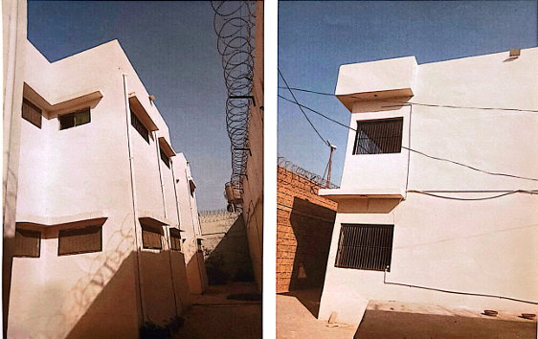
Photo ID: Pic-16
Project ID: Not found
What the photo shows:
Before / During / After:

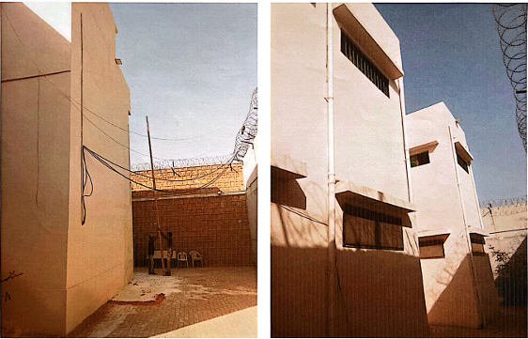
Photo ID: Pic-17
Project ID: Not found
What the photo shows:
Before / During / After:

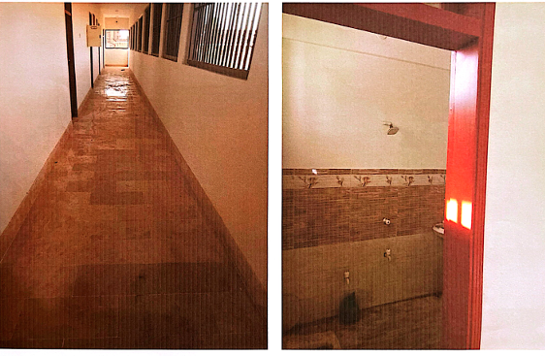
Photo ID: Pic-18
Project ID: Not found
What the photo shows:
Before / During / After:

Step 10 — Evidence Strength
Project | Evidence Strength | Reason
P-01 | Moderate | Listed in project records; detailed work-order verification pending
P-02 | Moderate | Listed in project records; detailed work-order verification pending
P-03 | Moderate | Listed in project records; detailed work-order verification pending
P-04 | Moderate | Listed in project records; detailed work-order verification pending
P-05 | Moderate | Listed in project records; detailed work-order verification pending
P-06 | Moderate | Listed in project records; detailed work-order verification pending
P-07 | Moderate | Listed in project records; detailed work-order verification pending
P-08 | Moderate | Listed in project records; detailed work-order verification pending
P-09 | Moderate | Listed in project records; detailed work-order verification pending
P-10 | Moderate | Listed in project records; detailed work-order verification pending
P-11 | Strong | Detailed project description recorded in company profile
P-12 | Strong | Detailed project description and scope recorded
P-13 | Moderate | Project identified, but supporting documentation not yet mapped
P-14 | Moderate | Project identified, but supporting documentation not yet mapped
P-15 | Moderate | Project identified, but supporting documentation not yet mapped
P-16 | Moderate | Project identified, but supporting documentation not yet mapped

Important:
These ratings are preliminary. They can change when we complete the document and photograph verification.

Step 11 — Project Classification
Now we decide what role each project should have in the future website portfolio.
The roadmap gives us these five classifications:
- Flagship Project — strongest projects, potentially deserving individual pages
- Supporting Project — useful evidence, but not necessarily a full page
- Portfolio Listing — suitable for a basic project list/card
- Source-Only — retained internally as evidence, not recommended for public portfolio
- Needs Verification — not enough verified information yet
For P-01–P-16, we should not make final classifications yet, because important evidence is still pending.

Preliminary classification
Project | Classification
P-01 | Needs Verification
P-02 | Needs Verification
P-03 | Needs Verification
P-04 | Needs Verification
P-05 | Needs Verification
P-06 | Needs Verification
P-07 | Needs Verification
P-08 | Needs Verification
P-09 | Needs Verification
P-10 | Needs Verification
P-11 | Needs Verification
P-12 | Needs Verification
P-13 | Needs Verification
P-14 | Needs Verification
P-15 | Needs Verification
P-16 | Needs Verification

Why all are currently "Needs Verification"
We still need to finish things like:
- supporting-document verification
- exact project values/dates
- photograph mapping
- duplicate/relationship review
- confirmation of website suitability

Step 12 — Individual Project Page Recommendation
Now we decide whether each project could eventually deserve its own page on the website.
For now, this is preliminary, because Step 9 photo mapping and full verification are still pending.
Project | Individual Project Page
P-01 | Pending verification
P-02 | Pending verification
P-03 | Pending verification
P-04 | Pending verification
P-05 | Pending verification
P-06 | Pending verification
P-07 | Pending verification
P-08 | Pending verification
P-09 | Pending verification
P-10 | Pending verification
P-11 | Potential individual page
P-12 | Potential individual page
P-13 | Pending verification
P-14 | Pending verification
P-15 | Pending verification
P-16 | Pending verification

Why P-11 and P-12 stand out:
Their records contain a more clearly defined building type and scope, making them possible candidates for individual project pages. But we're not making the final website decision yet.
For P-01–P-10, we especially need to resolve whether the repeated entries are actually separate projects.

Step 13 — Group Projects by Real Project Type
Now we organize the projects into real categories based on their actual scope.

P-01 to P-10
Category: Road / Street Improvement
Work: Street improvement / paving block work

P-11
Category: Residential / Government Building
Work: Police residential accommodation — 20 flats, G+4

P-12
Category: Police / Government Building
Work: Category-C Police Station construction

P-13
Category: Education / School
Work: School repair / renovation

P-14
Category: Education / School
Work: School re-construction

P-15
Category: Education / School
Work: Middle School → High School up-gradation

P-16
Category: Education / College
Work: College renovation
Category | Projects
Road / Street Improvement | P-01–P-10
Residential / Government Building | P-11
Police / Government Building | P-12
Education | P-13–P-16
Remember: P-01–P-10 being in the same category does not mean they are duplicates. Their individual identities are still pending verification.

Step 14 — Prepare the Final Project Master List
Now we put everything we've collected into one master list.
This is still a working master list, not the final locked version, because some verification is still pending.
ID | Project | Type | Status | Evidence | Duplicate Check
P-01 | Improvement Street / Providing & Fixing Paving Block | Road / Street | Completed — source-listed | Moderate | Pending
P-02 | Improvement Street / Providing & Fixing Paving Block | Road / Street | Completed — source-listed | Moderate | Pending
P-03 | Improvement Street / Providing & Fixing Paving Block | Road / Street | Completed — source-listed | Moderate | Pending
P-04 | Improvement Street / Providing & Fixing Paving Block | Road / Street | Completed — source-listed | Moderate | Pending
P-05 | Improvement Street / Providing & Fixing Paving Block | Road / Street | Completed — source-listed | Moderate | Pending
P-06 | Improvement Street / Providing & Fixing Paving Block | Road / Street | Completed — source-listed | Moderate | Pending
P-07 | Improvement Street / Providing & Fixing Paving Block | Road / Street | Completed — source-listed | Moderate | Pending
P-08 | Improvement Street / Providing & Fixing Paving Block | Road / Street | Completed — source-listed | Moderate | Pending
P-09 | Improvement Street / Providing & Fixing Paving Block | Road / Street | Completed — source-listed | Moderate | Pending
P-10 | Improvement Street / Providing & Fixing Paving Block | Road / Street | Completed — source-listed | Moderate | Pending
P-11 | Residential Accommodation for Constable & Head Constable — PHQ Garden | Residential / Government | Completed — source-listed | Moderate | Related to P-19
P-12 | Construction of Police Station (Category-C) at Pirabad | Police / Government | Completed — source-listed | Moderate | No apparent duplicate
P-13 | Repair/Renovation of GBPS Shah Faisal Jamia Mallia | Education | Completed — source-listed | Moderate | Pending
P-14 | Re-Construction of GBPS Natha Khan | Education | Completed — source-listed | Moderate | Pending
P-15 | Up-Gradation of GBMS Rehri Bakhtawar Goth | Education | Completed — source-listed | Moderate | Pending
P-16 | Renovation of Government Degree Boys College Moro | Education | Completed — source-listed | Moderate | Pending

What this gives us:
16 project records organized
Stable IDs preserved
Project types grouped
Status recorded
Duplicates still need final verification
Photos still need mapping
Dates/values/supporting documents still need verification

Step 15 — Issues Log
Now we record everything that still needs clarification or verification.
This is important because we don't want to lose track of unresolved information.
Current Issues Log
Issue | Problem | Status
I-01 | Company year is shown as 2008 in one section and 2009 in another | Open
I-02 | P-01–P-10 have very similar/repeated paving descriptions; need individual work-order comparison | Open
I-03 | P-11 and P-19 have very similar project details and may be related | Open
I-04 | Project dates for P-01–P-16 have not been fully verified | Open
I-05 | Project values for several projects have not been fully verified | Open
I-06 | Photographs have not yet been mapped to Project IDs | Open
I-07 | Supporting documents have not yet been completely mapped to individual projects | Open
I-08 | Final website classification for projects is still pending verification | Open
I-09 | Historical “Work in Hand” projects need confirmation of their actual final status before being described publicly | Open
I-10 | PEC certificate shown in the profile has validity until 30 June 2026; current renewal/validity needs confirmation before public use | Open

Step 16 — Final Review & Lock
This is the last step of Phase 1.
The roadmap says we can only LOCK Phase 1 when the Project Master List, Photograph Mapping Sheet, and Issues & Questions Log are complete and reviewed.
Current review
Requirement | Status
Raw Project List | Complete
Stable Project IDs | P-01–P-19
Initial Master Records | Started
Duplicate / Relationship Review | Pending final evidence
Conflict Log | Open issues remain
Date Verification | Pending
Scope | Recorded
Photograph Mapping | Not completed
Evidence Assessment | Preliminary
Project Classification | Preliminary
Issues Log | Created
Final Master List | Working version

Phase 1 status:
NOT LOCKED YET.
And that's actually the correct result—we shouldn't move to the next phase while important evidence is still unmapped or unverified.

What remains before we can lock
The biggest unfinished piece is:
Step 9 — Photograph-to-Project Mapping
After that, we'll need to resolve the important open issues and do the final review.
So Phase 1 is not complete yet, even though we've gone through Steps 1–16 once. The later steps revealed information that still needs to be finished.

